System Design Description (SysDD) Test Consumer

**Abstract**

This document provides the main template for the description of Arrowhead Systems technological implementations. In this document the solution for the actual implementation of the System is pointed out.

This document is an optional one. If the actual implementation is not needed, the usage of the System Description document should be adequate to reveal the interfaces and services.

All Arrowhead Systems should be specified using this template and stored on a common repository (available in the SVN Server), in order to document and formalize the pilot demonstrators.

* 1. System Design Description Overview 3

1. Internal structure 3
   1. Decomposition of the System 4
2. Revision history 5
   1. Amendments 5
   2. Quality Assurance 6

## System Design Description Overview

**Table 1 System Information**

|  |  |
| --- | --- |
| **Name** | Test Consumer |
| **Owner** | Gustav Hansson |

The Test Consumer provides an example on how to create a Consumer System using the custom Arrowhead C# Client library. The library has a Client and an Admin part where the Client is mandatory for service registration and orchestration whereas the Admin module is optional. The main functionality of the Admin module is to create intracloud rules and store entries in the Orchestrator. These can also be done manually via the API or using the Management Tools provided by the Arrowhead Tools project.

**Table 2 Pointers to SysD documents**

|  |  |
| --- | --- |
| **System name** | **Path** |
| Test Producer | “./SySD Test Consumer.docx” |

## Internal structure

**Table 4 Program files**

|  |  |
| --- | --- |
| Consumer | 1. https://github.com/97gushan/arrowhead-client-example/tree/master/consumer |
| Client Library | 1. https://github.com/97gushan/arrowhead-client-library |
| Grapevine | 1. https://github.com/sukona/Grapevine |

## Decomposition of the System

This system was developed in C# using the Arrowhead C# Client library. To call the Producers REST API the Grapevine HTTP Client is utilized.

Consumer project structure:

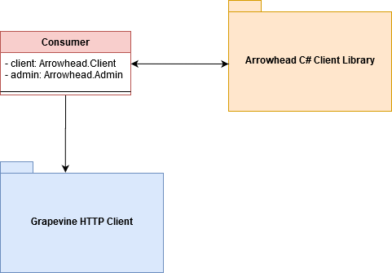

Class diagram of the Arrowhead C# Library:

## Revision history

## Amendments

|  |  |  |  |  |
| --- | --- | --- | --- | --- |
| No. | Date | Version | Subject of Amendments | Author |
| 1 | 2020-12-10 | 0.1 | First Draft | Gustav Hansson |
| 2 |  |  |  |  |

## Quality Assurance

|  |  |  |  |
| --- | --- | --- | --- |
| No. | Date | Version | Approved by |
| 1 |  |  |  |
| 2 |  |  |  |